**Design Thinking Project Workbook**

**Don't find customers for your product but find products for your customers**

**1. Team**

**Team Name:**

**Team Logo (if any):**

**Team Members:**

1. [Rithika Manyam, 2320040007, 7396213527]
2. [Munny, 2320040006, 6304771010]
3. [Navya, 2320040107, 9182397685]

**2. Problem/Opportunity Domain**

**Domain of Interest:** The domain of interest is job searching and guidance in the job. Which helps to find the suitable job and help people to make career and educational decisions.

**Description of the Domain:** The aim is to develop a chatbot for career search that will be good for their skill. What companies can heir them with the skills they have, or do they need to learn any new skill for better care in the future.

**Why did you choose this domain?:**I chose the domain chatbot for career search and job guidance because few people are getting jobs based on their skills, and a few are not able to know what skill they need to get the job.

**3. Problem/Opportunity Statement**

**Problem Statement:** This project works by machine learning and artificial intelligence, which is used for the future of job search how to find or get perfect path type and will help that del it would be great of job search. It will also help to search the job base on the skill that they have.

**Problem Description:** To develop a chatbot for job search based on machine learning and artificial intelligence to help people find the correct path for finding a job and for future career opportunities. To get the job based on their skill and the post they want to work.

**Context (When does the problem occur):**

· **Lack of Clarity**: Individuals may feel unsure about their career goals or interests, making it difficult to identify suitable job opportunities.

· **Limited Experience**: Recent graduates or those transitioning careers might struggle to present relevant experience, leading to frustration in the job search.

· **Market Conditions**: Economic downturns or industry-specific declines can create a competitive job market, making it harder to secure positions.

· **Networking Challenges**: Some individuals may find it difficult to build professional connections, limiting access to job leads and mentorship.

· **Skill Gaps**: Candidates may realize they lack the necessary skills or qualifications for desired roles, leading to feelings of inadequacy.

· **Overwhelming Options**: The vast number of job listings and career paths can create confusion, making it hard to focus on the right opportunities.

· **Application Fatigue**: Repeated rejections or a lengthy application process can lead to burnout and discouragement.

· **Geographical Limitations**: Relocation constraints or preference for remote work can restrict available job options.

**Alternatives (What does the customer do to fix the problem):**

· **Career Counselling**: Seeking help from career coaches or counsellors to gain clarity on career goals and strategies.

· **Networking Events**: Attending industry-specific networking events or job fairs to meet professionals and learn about opportunities.

· **Online Learning**: Enrolling in courses or certifications to bridge skill gaps and enhance qualifications for desired roles.

· **Professional Groups**: Joining online communities or professional organizations to connect with others in their field and share resources.

· **Resume Workshops**: Participating in workshops to improve resume writing and interview skills.

· **Informational Interviews**: Conducting informational interviews with professionals in desired fields to gather insights and advice.

· **Job Search Platforms**: Utilizing job boards and career websites to filter and find relevant job listings based on specific criteria.

**Customers (Who has the problem most often):**

· **Recent Graduates**: Students entering the job market who may lack experience and clarity about their career paths.

· **Career Changers**: Individuals looking to switch fields, often facing uncertainty about how to leverage their existing skills in a new industry.

· **Unemployed Individuals**: Those who have been out of work for an extended period and may feel discouraged or overwhelmed by the job search process.

· **Underemployed Workers**: Individuals working in jobs that don’t utilize their skills or education, seeking better opportunities.

· **Professionals Returning to Work**: Individuals re-entering the workforce after a break (e.g., parents, caregivers) who may face challenges in updating their skills or resumes.

· **Recent Immigrants**: Newcomers to a country who may struggle with language barriers, cultural differences, and understanding local job markets.

· **Low-Income Individuals**: Those who may have limited access to resources, networks, or educational opportunities, making the job search more challenging.

**Emotional Impact (How does the customer feel):**

· **Anxiety**: Worry about the future and the uncertainty of securing a suitable job can create significant stress.

· **Frustration**: Repeated rejections or a lack of responses can lead to feelings of irritation and hopelessness.

· **Overwhelm**: The vast number of job options and information can be daunting, making it hard to focus or decide on a direction.

· **Insecurity**: A lack of confidence in one’s skills or qualifications can result in self-doubt and negative self-talk.

· **Isolation**: The job search can feel lonely, especially for those who struggle to connect with others or build a network.

· **Disappointment**: Unrealistic expectations or unmet goals can lead to feelings of disappointment and sadness.

**Quantifiable Impact (What is the measurable impact):**

**Lack of Clarity**: Individuals may feel unsure about their career goals or interests, making it difficult to identify suitable job opportunities.

**Limited Experience**: Recent graduates or those transitioning careers might struggle to present relevant experience, leading to frustration in the job search.

**Market Conditions**: Economic downturns or industry-specific declines can create a competitive job market, making it harder to secure positions.

**Networking Challenges**: Some individuals may find it difficult to build professional connections, limiting access to job leads and mentorship.

**Skill Gaps**: Candidates may realize they lack the necessary skills or qualifications for desired roles, leading to feelings of inadequacy

**Overwhelming Options**: The vast number of job listings and career paths can create confusion, making it hard to focus on the right opportunities.

**Application Fatigue**: Repeated rejections or a lengthy application process can lead to burnout and discouragement.

**Geographical Limitations**: Relocation constraints or preference for remote work can restrict available job options.

**Cultural Fit Concerns**: Anxiety about finding a company that aligns with personal values and work style can complicate decision-making.

**Alternative Shortcomings (What are the disadvantages of the alternatives):**

· **Job Search Platforms**:

* **Overwhelming Volume**: The sheer number of job postings can make it hard to filter out relevant opportunities, leading to confusion.
* **Scams and Low-Quality Listings**: Some platforms can include scams or postings that are misleading or outdated.

· **Mentorship Programs**:

* **Finding a Good Match**: Pairing with a mentor who is truly helpful and invested in the mentee's success can be difficult.
* **Time Commitment**: Both mentors and mentees may struggle to find the time to engage meaningfully.

· **Volunteering or Internships**:

* **No Pay**: Many volunteering opportunities are unpaid, which may not be feasible for those needing immediate income.
* **Limited Career Advancement**: Not all volunteering or internships lead to job offers or meaningful career progression.

· **Personal Branding**:

* **Complexity**: Building a personal brand online can be complex and time-consuming, requiring skills many may not have.
* **Privacy Concerns**: Oversharing on platforms like LinkedIn can lead to privacy issues or unwanted attention.

**Any Video or Images to showcase the problem:**

[**https://drive.google.com/file/d/1Vs7JuGHojLDL56KtBxLYfsV2v1PyVsfA/view?usp=sharing**](https://drive.google.com/file/d/1Vs7JuGHojLDL56KtBxLYfsV2v1PyVsfA/view?usp=sharing)

**3. Addressing SDGs**

**Relevant Sustainable Development Goals (SDGs):**

· **SDG 4: Quality Education**

* Ensuring access to quality education and skills training is vital for individuals seeking to enhance their employability.

· **SDG 5: Gender Equality**

* Addressing barriers faced by women in the job market promotes equal opportunities and fosters gender equality in employment.

· **SDG 8: Decent Work and Economic Growth**

* Promoting sustained economic growth through productive employment opportunities and decent work conditions is directly related to effective job guidance.

· **SDG 10: Reduced Inequalities**

* Career guidance can help reduce inequalities by providing support to marginalized groups, ensuring they have equal access to job opportunities.

· **SDG 1: No Poverty**

* Secure employment is essential for reducing poverty levels; effective career guidance can help individuals secure better-paying jobs.

· **SDG 3: Good Health and Well-Being**

* Employment can significantly affect mental health and well-being; job search challenges can lead to stress and anxiety.

**How does your problem/opportunity address these SDGs?:**

· **SDG 10: Reduced Inequalities**

* **Contribution**: Offering inclusive career guidance services helps marginalized groups, such as low-income individuals or recent immigrants, access job opportunities. This reduces economic disparities and fosters social inclusion.

· **SDG 1: No Poverty**

* **Contribution**: By facilitating access to well-paying jobs through effective career guidance, individuals can achieve financial stability, reducing poverty levels. Employment not only provides income but also improves quality of life and community resilience.

· **SDG 3: Good Health and Well-Being**

* **Contribution**: Addressing job search challenges can alleviate stress and anxiety related to unemployment, contributing to better mental health outcomes. Secure employment leads to increased well-being and stability for individuals and families.

· **SDG 17: Partnerships for the Goals**

* **Contribution**: Developing partnerships between educational institutions, employers, and career services can create comprehensive support systems for job seekers. Collaborative efforts can lead to shared resources, best practices, and enhanced job placement strategies.

**4. Stakeholders**

Answer these below questions to understand the stakeholder related to your project

1. **Who are the key stakeholders involved in or affected by this project?**

· **Job Seekers**: Individuals actively searching for employment, including recent graduates, career changers, and those re-entering the workforce.

· **Employers**: Companies and organizations looking to hire talent, as they have a vested interest in finding qualified candidates who fit their needs.

· **Career Counsellors and Coaches**: Professionals providing guidance and support to job seekers, helping them navigate the job market and develop skills.

· **Educational Institutions**: Schools, colleges, and universities that play a role in preparing students for the workforce and may offer career services.

· **Professional Organizations**: Groups that represent specific industries and provide resources, networking opportunities, and support for job seekers.

· **Government Agencies**: Organizations that oversee workforce development, labor regulations, and employment services, often providing funding and resources for job training programs.

· **Nonprofits and Community Organizations**: Entities that offer support services, training, and resources to underrepresented or disadvantaged groups in the job market.

· **Mentors and Advisors**: Experienced professionals who guide and support job seekers, helping them build networks and gain insights into their chosen fields.

1. **What roles do the stakeholders play in the success of the innovation?**

· **Government Agencies**:

* **Policy Support**: Implementing policies and funding programs that support workforce development and job training initiatives.
* **Data Collection**: Gathering labor market data to inform stakeholders about current job trends and skills in demand.

· **Nonprofits and Community Organizations**:

* **Support Services**: Offering programs and resources for underrepresented groups, helping them access job opportunities and training.
* **Advocacy**: Raising awareness about barriers to employment and promoting inclusive practices in hiring.

· **Mentors and Advisors**:

* **Guidance and Support**: Providing one-on-one mentoring to help job seekers navigate their careers, build networks, and gain industry insights.
* **Encouragement**: Inspiring confidence and motivation in job seekers through personal stories and experiences.

· **Recruitment Agencies**:

* **Talent Matching**: Actively connecting job seekers with appropriate job openings, streamlining the hiring process for employers.
* **Market Insights**: Sharing insights on hiring trends and candidate preferences to improve the job search process.

· **Family and Friends**:

* **Emotional Support**: Providing encouragement and motivation to job seekers during challenging times in their search.

1. **What are the main interests and concerns of each stakeholder?**

### Job Seekers

**Interests:**

* Finding suitable job opportunities that match their skills and interests.
* Gaining necessary skills and knowledge for employment.

**Concerns:**

* Facing rejection or prolonged unemployment.
* Feeling overwhelmed by the job search process.

### 2. Employers

**Interests:**

* Finding qualified candidates who fit organizational needs and culture.
* Reducing time and costs associated with the hiring process.

**Concerns:**

* High turnover rates and the challenges of finding suitable candidates.
* Skills gaps among job seekers.
* Potential hiring biases affecting diversity and inclusion.

### 3. Career Counsellors and Coaches

**Interests:**

* Helping job seekers succeed in their employment journeys.
* Providing effective tools and resources to enhance job search skills.

**Concerns:**

* Limited resources or support to adequately assist job seekers.
* Variability in client engagement and motivation.

1. **How much influence does each stakeholder have on the outcome of the project?**

**B. Tech Students (Users)**

* Influence Level: High
* Rationale: As the primary users of the chatbot, their feedback and engagement directly impact the chatbot's design, functionality, and relevance. Their needs and experiences shape the overall effectiveness of the tool.

**Career Counsellors**

* Influence Level: Medium to High
* Rationale: Career counsellors can provide valuable insights into industry standards and user needs. Their expertise can help refine the chatbot's content and ensure it delivers useful guidance, but they may not be involved in day-to-day operations.

**Employers/Recruiters**

* Influence Level: Medium
* Rationale: Employers' expectations and requirements can shape the features of the chatbot, especially regarding job matching and skills assessment. However, their direct involvement may vary, depending on how the chatbot aligns with their hiring processes.

**Developers (Technical Team)**

* Influence Level: High
* Rationale: The development team has significant control over the technical aspects of the chatbot, including its functionality, user experience, and integration with other platforms. Their decisions will influence the feasibility of features and the overall performance of the chatbot.

**Project Stakeholders (Investors, Institutions)**

* Influence Level: Medium
* Rationale: Investors and institutions may have a say in the project's direction, funding, and overall goals. Their influence may be more about strategic decisions rather than daily operations, but they can impact resource allocation.

**Feedback Groups (Focus Groups, Beta Testers)**

* Influence Level: Medium
* Rationale: These groups can provide targeted feedback during testing phases, helping identify usability issues and areas for improvement. Their insights can influence final adjustments before the official launch.

**Content Experts (Industry Professionals, Educators)**

* Influence Level: Medium
* Rationale: Their knowledge about industry trends, required skills, and effective career guidance can enhance the content provided by the chatbot, ensuring it remains relevant and useful to users.

1. **What is the level of engagement or support expected from each stakeholder?**

• **Project Manager:** High engagement in planning, resource allocation, and monitoring progress to ensure project milestones are met.

• **Engineers/Technicians:** Active support in design, implementation, and troubleshooting of the circuit, providing technical expertise throughout the project.

• **End Users:** Participation in testing and providing feedback on the functionality and usability of the motor control system to ensure it meets their needs.

• **Suppliers:** Reliable support in providing components on time and addressing any issues related to quality or availability of parts.

• **Stakeholders (e.g., investors or management):** Periodic updates and involvement in key decision-making processes, ensuring alignment with business goals and expectations.

1. **Are there any conflicts of interest between stakeholders? If so, how can they be addressed?**

• **Users vs. Employers:** Users may seek personalized job matches based on their preferences, while employers might prioritize a broader candidate pool. This can be addressed by ensuring transparency in job listings and maintaining a balance between user-centric features and employer needs.

• **Developers vs. Project Managers:** Developers may want to implement innovative features, while project managers focus on budget and timeline constraints. Regular communication and compromise on project scope can help align goals.

• **Investors vs. Users:** Investors might prioritize monetization strategies that could compromise user experience. To address this, stakeholder meetings can be held to discuss user feedback and potential impacts on the chatbot's effectiveness.

• **Content Creators vs. Compliance Teams:** Content creators may aim for engaging, creative job guidance content, while compliance teams focus on legal and ethical standards. Establishing a collaborative review process can ensure that content meets both engagement and compliance requirements.

1. **How will you communicate and collaborate with stakeholders throughout the project?**

**Regular Meetings:** Schedule weekly or bi-weekly meetings to discuss project updates, address concerns, and gather feedback from all stakeholders.

**Progress Reports:** Provide periodic progress reports that summarize achievements, challenges, and upcoming tasks to keep everyone informed and aligned.

**Collaboration Tools:** Use project management and collaboration tools (like Trello, Asana, or Slack) to facilitate real-time communication, share documents, and track tasks.

**Feedback Sessions:** Organize dedicated sessions for users and stakeholders to provide feedback on the chatbot's functionality and features, ensuring their input is considered in the development process.

**Surveys and Polls:** Conduct surveys or polls to gather insights from users and stakeholders on specific features or changes, allowing for data-driven decision-making.

**Documentation:** Maintain clear and comprehensive documentation of project plans, requirements, and changes, ensuring all stakeholders have access to necessary information.

**Stakeholder Workshops:** Hold workshops or brainstorming sessions to foster collaboration and generate ideas for improving the chatbot and addressing user needs.

1. **What potential risks do stakeholders bring to the project, and how can these be mitigated?**

• **User Expectations:** Users may have unrealistic expectations about the chatbot's capabilities.  
Mitigation: Clearly communicate the chatbot's functionalities through onboarding tutorials and FAQs to set appropriate expectations.

• **Technical Challenges:** Developers may encounter unexpected technical issues that delay progress.  
Mitigation: Conduct thorough testing and implement agile methodologies to allow for iterative development and quick resolution of issues.

• **Compliance Risks:** Stakeholders may inadvertently introduce compliance risks related to data privacy and employment laws.  
Mitigation: Involve legal experts early in the project to review content and features, ensuring compliance with relevant regulations.

• **Lack of Engagement:** Investors or management may lose interest if progress is not communicated effectively.  
Mitigation: Provide regular updates and involve them in key decisions to maintain their interest and support.

• **Content Accuracy:** Content creators might produce outdated or inaccurate information, affecting user trust.  
Mitigation: Establish a review process that includes expert validation of job-related content to ensure accuracy and relevance.

• **Budget Overruns:** Stakeholders may push for additional features that exceed the budget.  
Mitigation: Clearly define project scope and budget constraints upfront, and prioritize features based on stakeholder feedback and project goals.

**5. Power Interest Matrix of Stakeholders**

**Power Interest Matrix:**

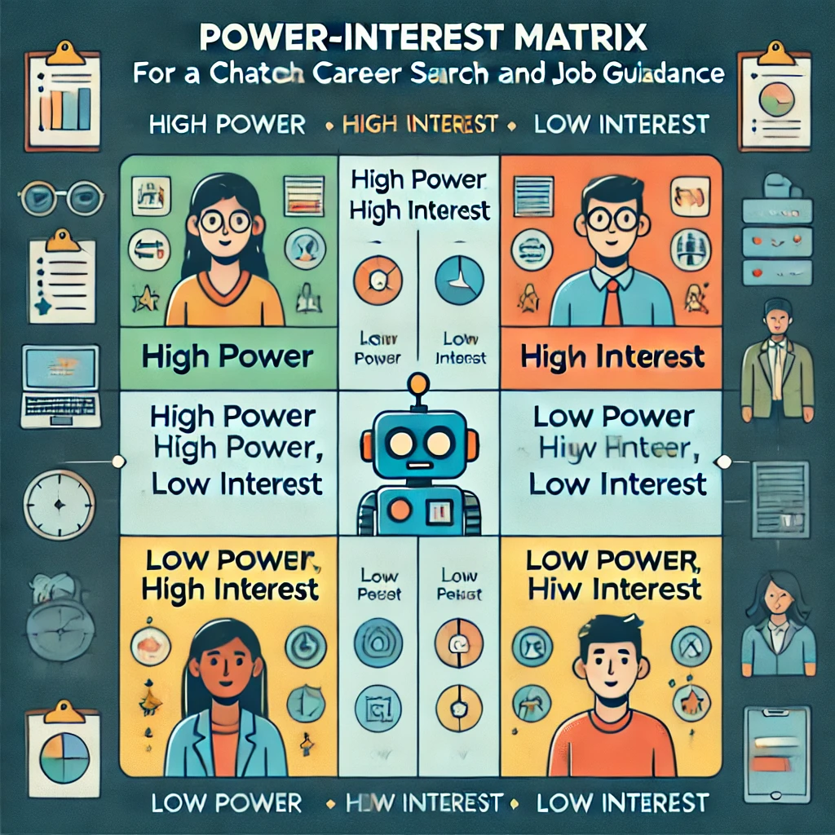

* High Power, High Interest: [Stakeholder Names]
* High Power, Low Interest: [Stakeholder Names]
* Low Power, High Interest: [Stakeholder Names]
* Low Power, Low Interest: [Stakeholder Names]

1. **Empathetic Interviews**

**Conduct Skilled interview with at least 30 citizens/Users by asking open ended questions (What, why/How etc) and list the insights as per the format below**

|  |  |  |
| --- | --- | --- |
| **I need to know**  **(thoughts, feelings, actions)** | **Questions I will ask**  **(open questions)** | **Insights I hope to gain** |
| Thoughts |  |  |
|  |  |  |
|  |  |  |
| Feelings |  |  |
|  |  |  |
|  |  |  |
| actions |  |  |
|  |  |  |
|  |  |  |

**SKILLED INTERVIEW REPORT**

**(Examples are given. Erase them and fill with your user information.)**

|  |  |  |
| --- | --- | --- |
| **User/Interviewee** | **Questions Asked** | **Insights gained (NOT THEIR ANSWERS)** |
| Abhishek Verma,  Student | Which party do you vote for? | Citizens are not very open about their political preferences |
| Srinivasan P., Parent | How do you feel about the plans for a new capital? | Some citizens are sad that the capital is being relocated from Hyderabad. |
|  |  |  |
|  |  |  |
|  |  |  |

**Key Insights Gained:**

* **Insight 1**
* **Insight 2**

**Empathy Map**

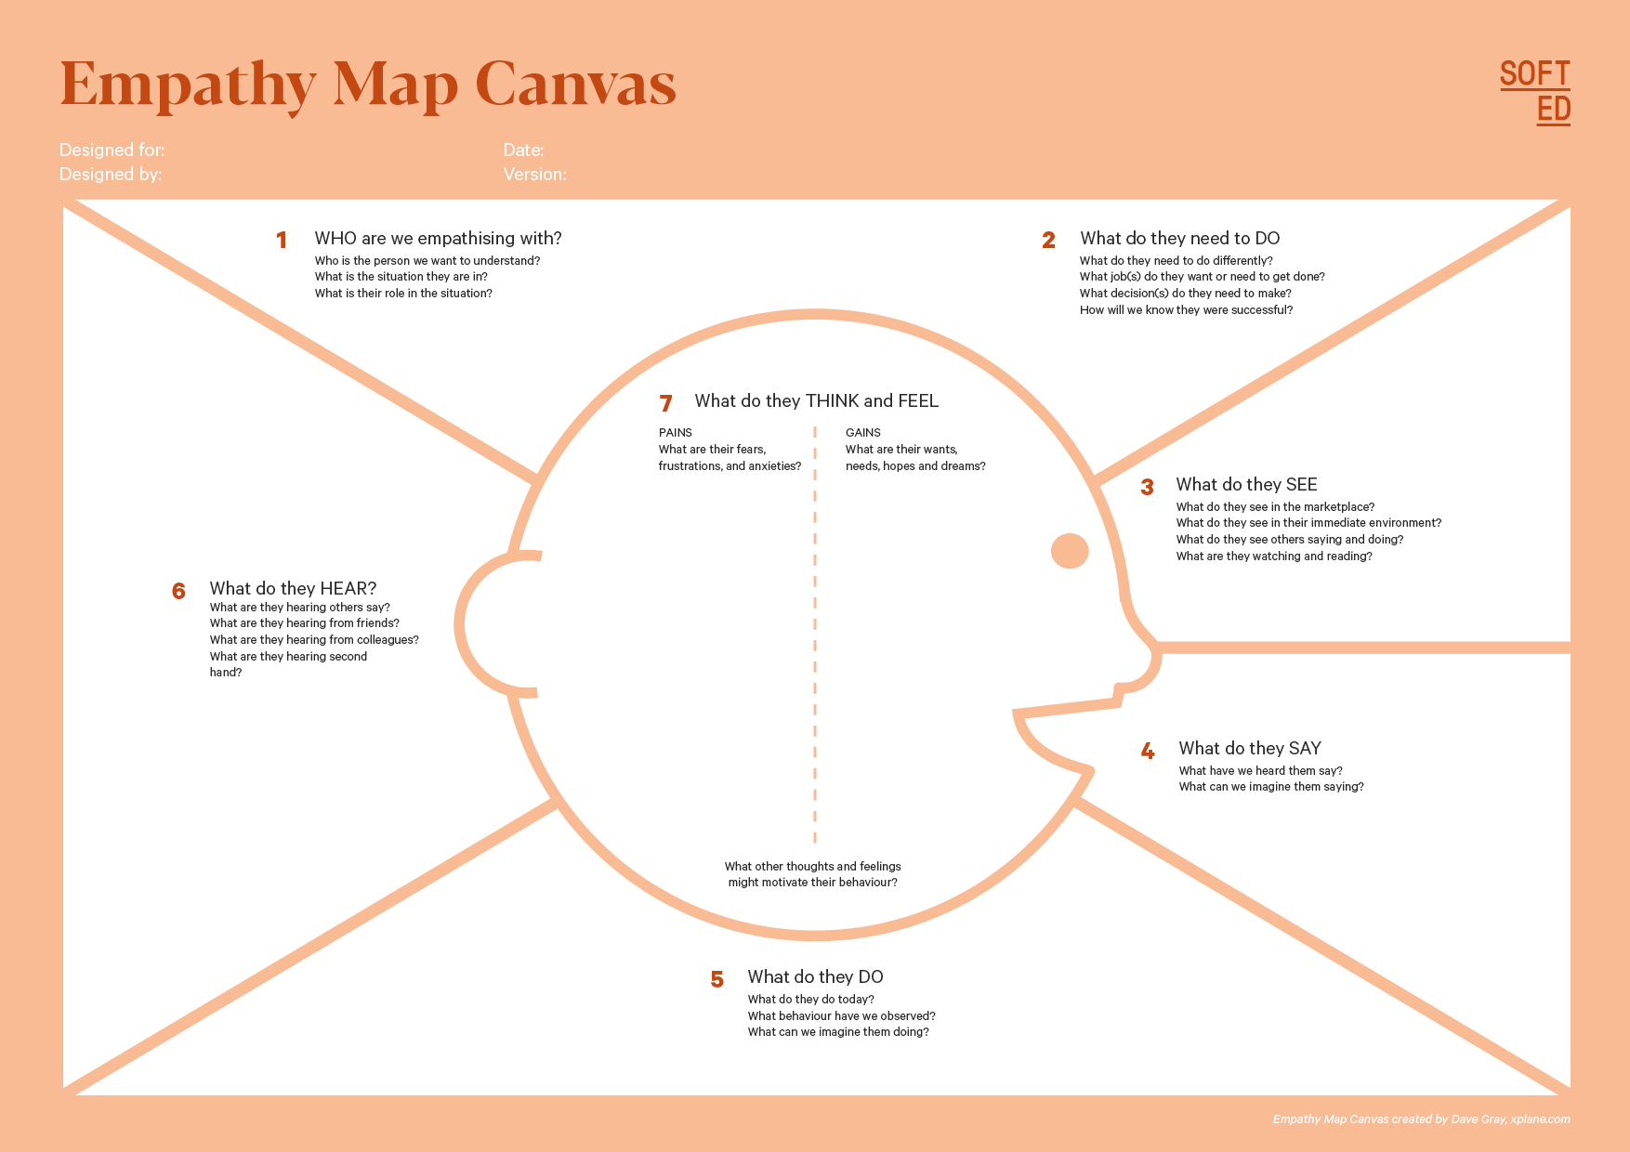

Your Answer:

Your Answer:

Who is your Customer Segment:

Idea/Innovation Title:

Designed By:

Date of Submission:

Your Answer:

Your Answer:

Your Answer:

Your Answer:

Your Answer:

Your Answer:

Your Answer:

1. **Empathy Map**
2. **Who is your Customer?**

**Description: This is where you specify the customer or user you are empathizing with. It could be a specific user persona or a general user segment.**

**Key points:**

* **Define the customer profile clearly (e.g., age, profession, interests).**
* **State their goals and needs related to the innovation or product.**
* **Context in which the user will interact with your solution.**

1. **Who are we empathizing with?**

**Description: This area helps you define who the user is, what their situation looks like, and what role they play. It emphasizes understanding the user’s perspective in depth.**

**Key points:**

* **Define the user's characteristics (e.g., personality, values, and responsibilities).**
* **State the user's goals and challenges in their environment.**
* **What is the user's broader situation (professionally or personally)?**

1. **What do they need to DO?**

**Description: This section identifies what actions or tasks the user needs to perform. It helps highlight the expectations and demands the user faces.**

**Key points:**

* **Clarify the tasks or actions the user needs to complete.**
* **What decisions do they need to make?**
* **How do they define success or failure in their tasks?**

1. **What do they SEE?**

**Description: This focuses on the visual stimuli or environment that the user interacts with. It's important to consider what users see in their immediate surroundings and in their larger world.**

**Key points:**

* **What do users see in their physical and digital environment?**
* **What trends or competitors do they notice?**
* **How do these visual elements influence their behavior?**

1. **What do they SAY?**

**Description: This section captures what the user might say in public, such as comments or feedback they give in conversations or on social media.**

**Key points:**

* **What might users express openly in conversation about their problems?**
* **How do they express their goals or frustrations?**
* **What are their words during customer interviews or feedback?**

1. **What do they DO?**

**Description: This section focuses on what the user does, the actual behaviors they exhibit, and actions they take in different situations.**

**Key points:**

* **What observable actions do users take?**
* **What habits or routines do they follow?**
* **What might users do to try and solve their problems?**

1. **What do they HEAR?**

**Description: This addresses what information the user receives from external sources, such as colleagues, media, or industry trends. It helps map the influences surrounding the user.**

**Key points:**

* **What are they hearing from peers, mentors, or the industry?**
* **What media or channels of information are they exposed to?**
* **Are there any strong influencers guiding their behavior?**

1. **What do they THINK and FEEL?**

**Description: This is one of the most insightful sections, addressing the internal emotions, concerns, and motivations of the user. It helps identify their deep-rooted feelings.**

**Key points:**

* **What are their fears, worries, and anxieties?**
* **What are their motivations and desires?**
* **How do their thoughts and feelings align with their actions?**

1. **Pains and Gains**

**Description: This section focuses on the user’s frustrations and their desired outcomes. It helps to frame the user’s challenges (pains) and the benefits they seek (gains).**

**Key points:**

* **What are the user’s main pain points?**
* **What would make their life easier or more fulfilling?**
* **What benefits do they hope to achieve from your product or solution?**

**8. Persona of Stakeholders**

**Stakeholder Name:**

**Demographics: Key characteristics of your target audience, such as age, gender, income, and location.**

**Goals: What the stakeholders or customers want to achieve in relation to the innovation.**

**Challenges: The obstacles or difficulties faced by stakeholders that the innovation aims to address.**

**Aspiration: The long-term desires or dreams of your target audience related to the innovation.**

**Needs: The essential requirements of your customers or stakeholders that must be met.**

**Pain Points: Specific problems or frustrations experienced by the target audience.**

**Storytelling: A narrative that highlights the journey of the stakeholder or customer, illustrating the problem and how the innovation can solve it.**

**Sample:**

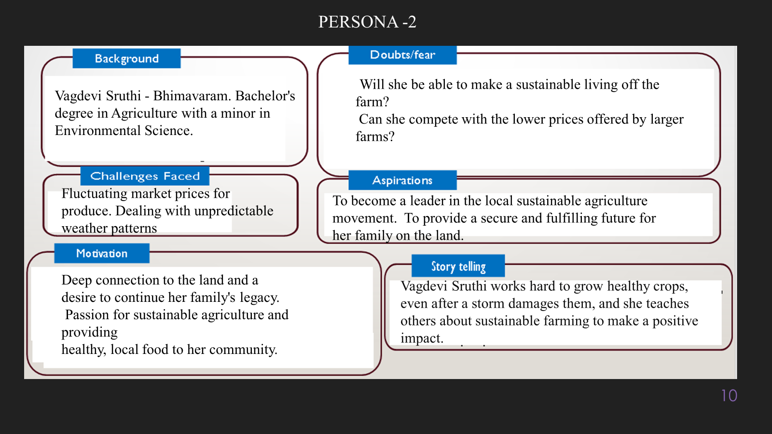

**10. Look for Common Themes, Behaviors, Needs, and Pain Points among the Users**

Analyse the data from your affinity diagram to uncover recurring patterns among your users, helping you better understand their expectations and challenges.

**Common Themes: Identify broad ideas or issues that repeatedly appear across different groups in your affinity diagram.**

**Common Behaviors: Observe how users consistently act or respond in relation to the problem or product throughout their journey.**

**Common Needs: Pinpoint essential requirements or desires that many users share, highlighting what they need for a better experience.**

**Common Pain Points: Look for frustrations or obstacles that frequently hinder the user experience, which your project can address.**

**12. Define Needs and Insights of Your Users**

**User Needs: Define the core requirements your users have in relation to the problem or product. These could be functional, emotional, or societal needs that your solution must address.**

**User Insights: Summarize the key understandings or observations you've uncovered about your users' behaviors, motivations, and pain points. These insights provide a deeper understanding of why users behave the way they do and what drives their decisions.**

**13. POV Statements**

**POV Statements:**

* [User] needs a way to [need] because [insight].

|  |  |  |  |
| --- | --- | --- | --- |
| PoV Statements  (At least ten) | Role-based or Situation-Based | Benefit, Way to Benefit,  Job TBD,  Need (more/less) | PoV Questions  (At least one per statement) |
| (Erase this example) When I drive to work, I want to avoid traffic jams so I don’t get in trouble with my boss for being late. | Situation | Way to Benefit | What can we design that will enable drivers to avoid traffic jams?  What can we design that will enable workers to avoid getting in trouble for being late to work? |
|  |  |  |  |
|  |  |  |  |
|  |  |  |  |
|  |  |  |  |

**14. Develop POV/How Might We (HMW) Questions to Transform Insights/Needs into Opportunities for Design**

Turn your user needs and insights into actionable opportunities by framing them as "How Might We" (HMW) questions. These questions will spark creative problem-solving and guide your innovation process.

1. **How Might We: Based on the needs and insights you've identified, create open-ended questions starting with "How might we...?" These questions should aim to solve user pain points, enhance the experience, or address specific needs.**

**Examples:**

* **User Need: "Users need a quicker way to access customer support."**
  + **HMW Question: "How might we create a more efficient and accessible customer support system?"**
* **Insight: "Users feel overwhelmed by too many options."**
  + **HMW Question: "How might we simplify decision-making for our users?"**

**Task:**

**Write 3-5 "How Might We" questions based on your analysis of user needs and insights. These questions should challenge you to think of innovative solutions that can address user problems in meaningful ways.**

**This task encourages participants to think creatively about solving user problems, transforming challenges into opportunities for innovation.**

|  |  |
| --- | --- |
| User Need/Insight | "How Might We" Question |
| [State the user need or insight clearly] | **How might we... [formulate an open-ended question to address the need or insight]?** |

**16. Crafting a Balanced and Actionable Design Challenge**

The Design Challenge Should Neither Be Too Narrow Nor Too Broad and It Should Be an Actionable Statement with a quantifiable goal. It should be a culmination of the POV questions developed.

**Design Challenge:** [Actionable Statement]

**17. Validating the Problem Statement with Stakeholders for Alignment**

Ensure your problem statement accurately represents the needs and concerns of your stakeholders and users. This involves gathering feedback from these groups to confirm that the problem is relevant and significant from their perspective. By validating early, you can refine the problem statement to better align with real-world challenges, ensuring your solution addresses the correct issues.

**Validation Plan:**

**Stakeholder/User Feedback (Min. 10 Stakeholders/Experts):**

|  |  |  |  |
| --- | --- | --- | --- |
| Stakeholder/User | Role | Feedback on Problem Statement | Suggestions for Improvement |
| [Name/Group] | **[Role/Title]** | **[Does the problem resonate with them? Why or why not?]** | **[Suggestions for refining the problem statement]** |
| [Name/Group] | **[Role/Title]** | **[Does the problem resonate with them? Why or why not?]** | **[Suggestions for refining the problem statement]** |

**18. Ideation**

**Ideation Process:**

|  |  |  |  |
| --- | --- | --- | --- |
| Idea Number | Proposed Solution | Key Features/Benefits | Challenges/Concerns |
| Idea 1 | **[Brief description of solution]** | **[What are the key benefits of this solution?]** | **[What challenges or concerns exist?]** |
| Idea 2 | **[Brief description of solution]** | **[What are the key benefits of this solution?]** | **[What challenges or concerns exist?]** |
| Idea 3 | **[Brief description of solution]** | **[What are the key benefits of this solution?]** | **[What challenges or concerns exist?]** |
| Idea 4 | **[Brief description of solution]** | **[What are the key benefits of this solution?]** | **[What challenges or concerns exist?]** |
| Idea 5 | **[Brief description of solution]** | **[What are the key benefits of this solution?]** | **[What challenges or concerns exist?]** |

**18. Idea Evaluation**

Evaluate the Idea based on 10/100/1000 grams

|  |  |  |  |  |
| --- | --- | --- | --- | --- |
| Idea | Impact (10/100/1000 grams) | Feasibility (10/100/1000 grams) | Alignment (10/100/1000 grams) | Total Weight |
| Idea 1 | **[Assign weight]** | **[Assign weight]** | **[Assign weight]** | **[Sum of weights]** |
| Idea 2 | **[Assign weight]** | **[Assign weight]** | **[Assign weight]** | **[Sum of weights]** |
| Idea 3 | **[Assign weight]** | **[Assign weight]** | **[Assign weight]** | **[Sum of weights]** |
| Idea 4 | **[Assign weight]** | **[Assign weight]** | **[Assign weight]** | **[Sum of weights]** |
| Idea 5 | **[Assign weight]** | **[Assign weight]** | **[Assign weight]** | **[Sum of weights]** |

**Example:**

|  |  |  |  |  |
| --- | --- | --- | --- | --- |
| Idea | Impact (10/100/1000 grams) | Feasibility (10/100/1000 grams) | Alignment (10/100/1000 grams) | Total Weight |
| Idea 1 | **1000** | **100** | **1000** | **2100** |
| Idea 2 | **100** | **1000** | **100** | **1200** |
| Idea 3 | **100** | **100** | **100** | **300** |

Further, use solution concept form to scrutinize the idea

**Solution Concept Form**

**1. Problem Statement:**

* **[State the validated problem your solution addresses.]**

**2. Target Audience:**

* **[Describe the main users or customers who will benefit from this solution.]**

**3. Solution Overview:**

* **[Provide a brief description of the solution concept.]**

**4. Key Features:**

| **Feature** | **Description** |
| --- | --- |
| **Feature 1** | **[Briefly describe the main feature of your solution]** |
| **Feature 2** | **[Briefly describe another key feature]** |
| **Feature 3** | **[Briefly describe a third key feature]** |

**5. Benefits:**

| **Benefit** | **Description** |
| --- | --- |
| **Benefit 1** | **[What value does this solution bring?]** |
| **Benefit 2** | **[How does this solution solve the problem?]** |
| **Benefit 3** | **[What makes this solution stand out?]** |

**6. Unique Value Proposition (UVP):**

* **[Summarize why this solution is unique and why it will appeal to your target audience.]**

**7. Key Metrics:**

| **Metric** | **Measurement** |
| --- | --- |
| **Metric 1** | **[What is the key metric to measure success?]** |
| **Metric 2** | **[What is another key metric for tracking progress?]** |

**8. Feasibility Assessment:**

* **[Provide a brief evaluation of how achievable or practical this solution is (consider resources, time, and technology).]**

**9. Next Steps:**

* **[Outline the next steps for further developing or prototyping this solution.]**